**SOFTWARE REQUIREMENT SPECIFICATION**

**for**

**LPG CYLINDERS DISTRIBUTOR SOFTWARE**

1. User Login:

*Description:* User Can Login into System using correct credentials

*Input:* Username and Password.

*Output:* Home window if Credentials is correct otherwise error message.

1. Customer Management:

*Description:* Using this Functionality distributor user can create new customer, remove customer, change customer details.

R2.1 Create Customer

*Input:* Customer Details like name, Aadhaar number, address, contact number, type of connection.

*Output:* Success Message “Customer created Successfully”.

R2.2 Change Customer Details

*Input:* Customer Details for change.

*Output:* Success Message “Customer details updated Successfully”.

R2.3 Remove Customer

*Input:* Customer ID or Name

*Output:* Success Message “Customer removed Successfully”.

R2.4 Customer Details

*Description:* Distributor user can search customer by connection type, date, village, and view customer details.

*Input:* Required data to search records.

*Output:* List of Customers as per Input.

R2.5 Transfer Customer

*Description:* Distributor user can transfer customers from his agency to another agency.

*Input:* Selection of records and destination agency name

*Output:* Success Message “Transfer of Customers is Successfully done”.

1. Stock Management:

*Description:* Distributor user can add, view stock and can set price for cylinders, stoves and regulators.

R3.1 Add Stock

R3.1.1 Add Cylinders

*Input:* Numbers of various types of cylinders

*Output:* Success message

R3.1.2 Add Stoves and Regulators

*Input:* Numbers of various types of stoves and regulators

*Output:* Success message

R3.2 View Stock

*Input:* User selection

*Output:* Stock details of cylinders, stoves and regulators.

R3.3 Set Price

*Description:* Distributor user can set prices of cylinders, stoves and regulators.

*Input:* Prices of cylinders, stoves and regulators.

*Output:* Successful message

1. Synchronization with Central Server:

*Description:* Distributor user can synchronize customer transactions, changes of customers’ details and stock data within given time period for a day.

*Input:* User selection

*Output:* Success message

*Process:* Transfer Local data like customer transactions, changes of customers’ details and stock data to central server.

1. Customer Transaction:

*Description:* Distributor user can book cylinders, print bill of cylinders, stoves and regulator.

R5.1 Book Cylinder

*Input:* User will search customer and select “Register Booking”.

*Output:* Successful message

*Process:* record of this transaction is saved in record with unique transaction number.

R5.2 Print Bill of Cylinder

*Input:* Single or multiple records of cylinder refilling.

*Output:* Bill will be printed for selected records.

R5.3 Print Bill for Stoves and Regulator

*Input:* Distributor user will enter details like customer name, stove and regulator quantity.

*Output:* Bill will be printed.

1. Accounting:

*Description:* Distributor user can get details of sold and purchased cylinders, stoves and regulators for period entered by user. User can also generate pdf of those details.

R6.1 Summary Report

*Input:* User Selection.

*Output:* Summarized Report.

R6.2 Cylinder Report

*Input:* User Selection.

*Output:* Report of Cylinders.

R6.3 Stove and Regulator Report

*Input:* User Selection.

*Output:* Report of Stoves and Regulator.

**DESIGN**

* 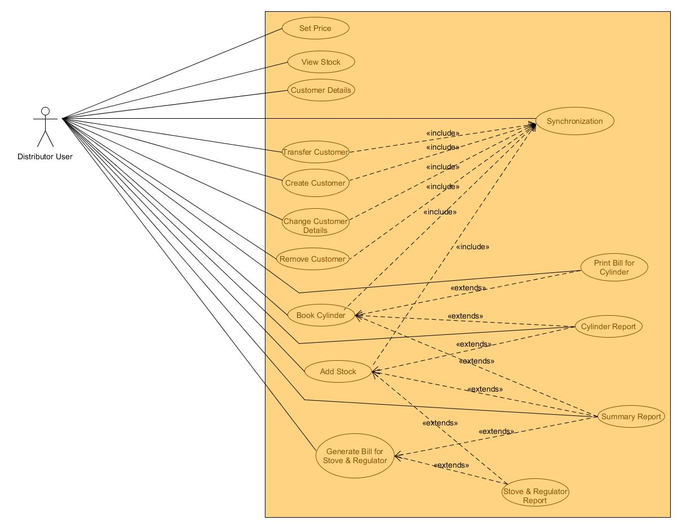**Use Case Diagrams:**
* 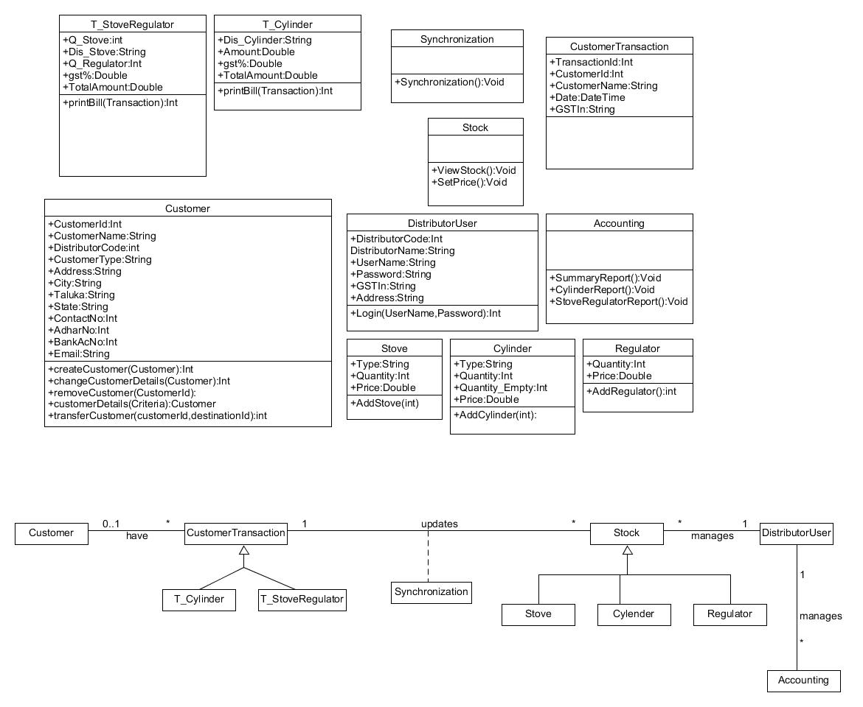**Class Diagrams:**
* 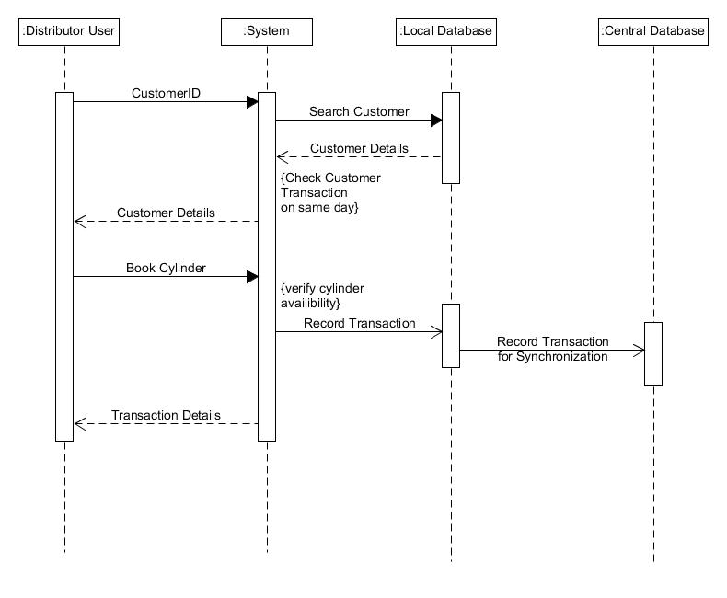**Sequence Diagrams:**
* **State Diagrams:**

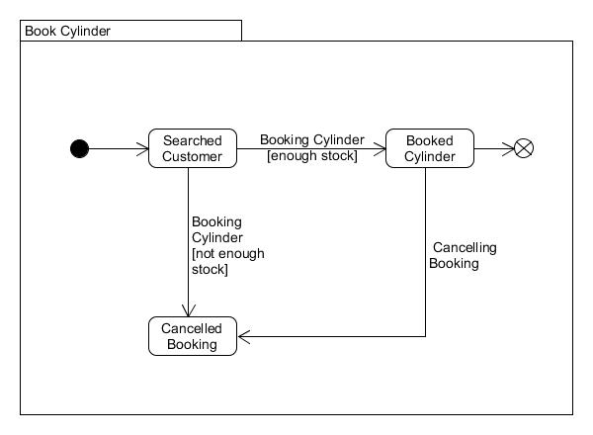

* 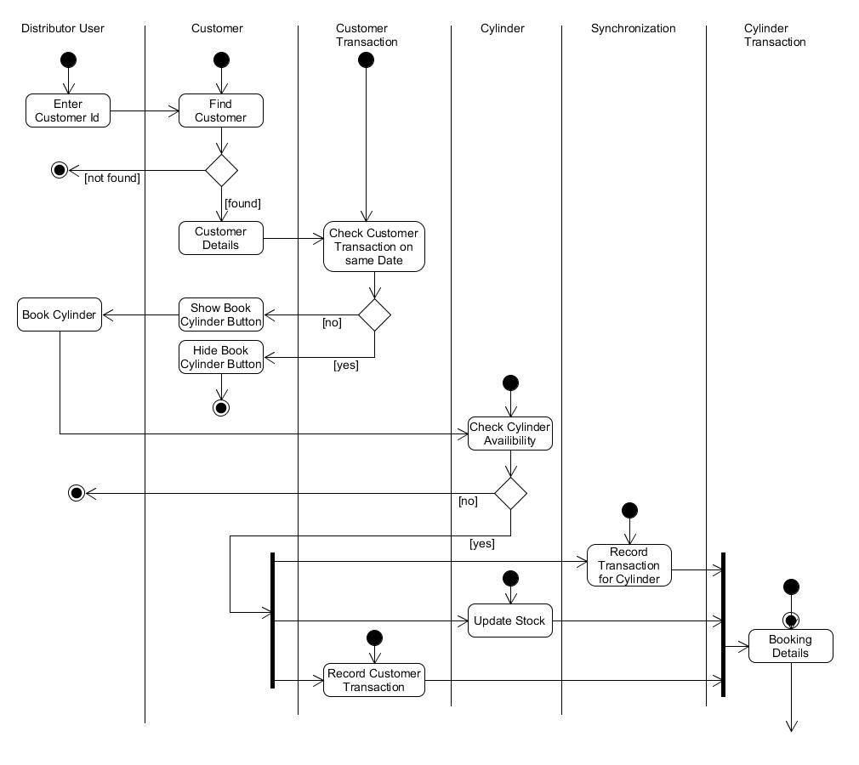**Activity Diagrams:**
* 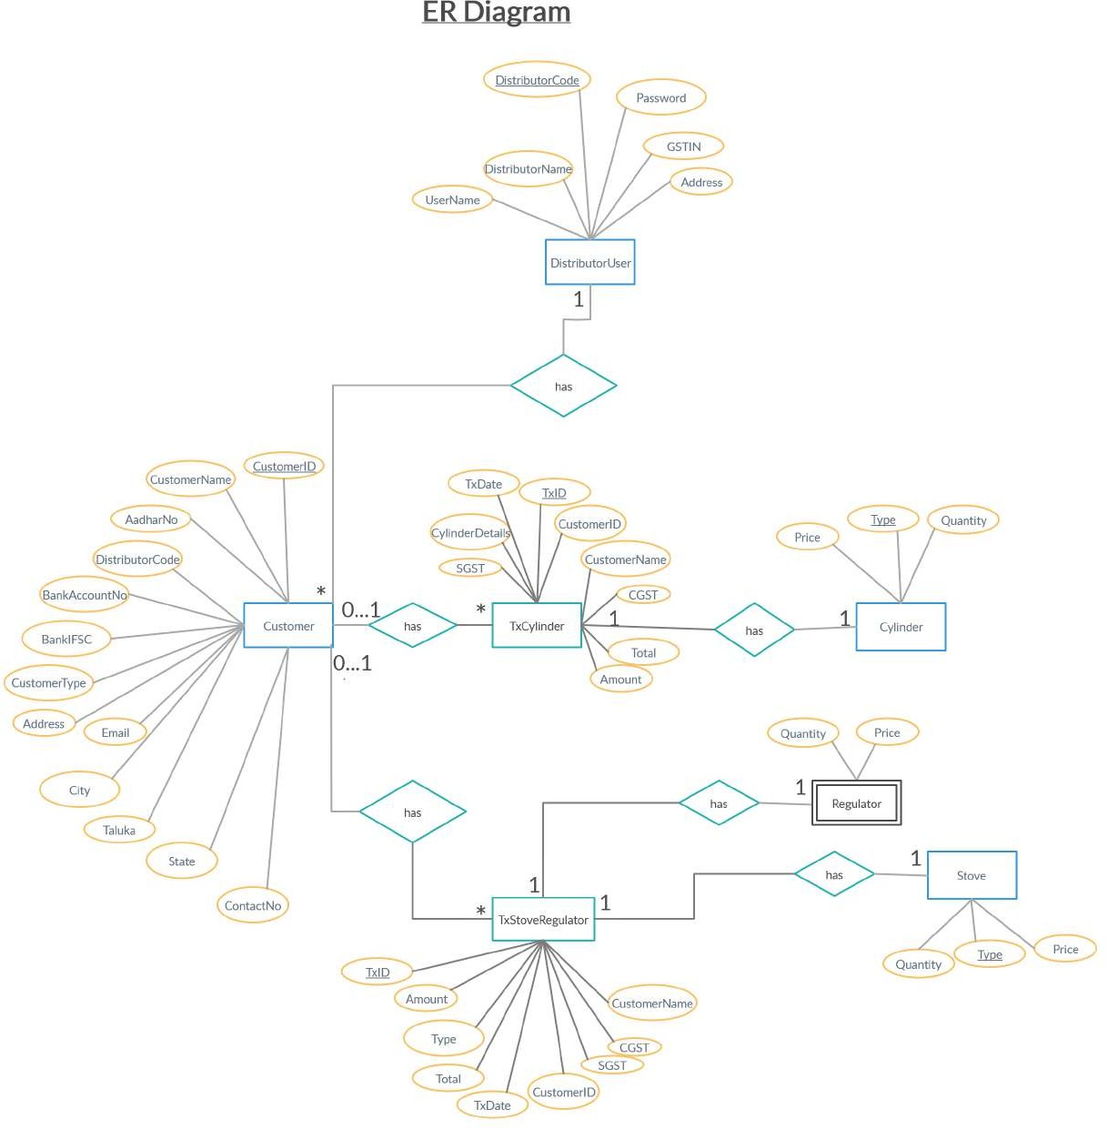**E-R Diagram:**
* **Data Dictionary:**

|  |  |  |  |  |  |  |  |
| --- | --- | --- | --- | --- | --- | --- | --- |
| **Customer** | | | | | | | |
| **Sr. No.** | **Field Name** | **Data Type** | **Width** | **Required** | **Unique** | **PK/FK** | **Referenced Table** |
| 1. | CustomerId | Int | 10 | Yes | Yes | PK |  |
| 2. | DistributorCode | Int | 6 | Yes |  | FK | DistributorUser |
| 3. | CustomerName | Varchar2 | 30 | Yes |  |  |  |
| 4. | CustomerType | Varchar2 | 10 | Yes |  |  |  |
| 5. | Address | Varchar2 | 100 | Yes |  |  |  |
| 6. | City | Varchar2 | 20 | Yes |  |  |  |
| 7. | Taluka | Varchar2 | 20 | Yes |  |  |  |
| 8. | State | Varchar2 | 20 | Yes |  |  |  |
| 9. | ContactNo | Int | 10 |  |  |  |  |
| 10. | Email | Varchar2 | 50 |  |  |  |  |
| 11. | AadharNo | Int | 12 | Yes | Yes |  |  |
| 12. | BankIFSC | Varchar2 | 15 |  |  |  |  |
| 13. | BankAccountNo | Int | 16 |  | Yes |  |  |

|  |  |  |  |  |  |  |  |
| --- | --- | --- | --- | --- | --- | --- | --- |
| **DistributorUser** | | | | | | | |
| **Sr.**  **No.** | **Field Name** | **Data Type** | **Width** | **Required** | **Unique** | **PK/FK** | **Referenced Table** |
| 1. | DistributorCode | Varchar2 | 6 | Yes | Yes | PK |  |
| 2. | DistributorName | varchar2 | 30 | Yes |  |  |  |
| 3. | Username | Varchar2 | 12 | Yes |  |  |  |
| 4. | Password | Varchar2 | 12 | Yes |  |  |  |
| 5. | GSTIN | Varchar2 |  | Yes | Yes |  |  |
| 6. | Address | Varchar2 | 100 | Yes |  |  |  |

|  |  |  |  |  |  |  |  |
| --- | --- | --- | --- | --- | --- | --- | --- |
| **Cylinder** | | | | | | | |
| **Sr. No.** | **Field Name** | **Data Type** | **Width** | **Required** | **Unique** | **PK/FK** | **Referenced Table** |
| 1. | Type | Varchar2 | 15 | Yes | Yes | PK |  |
| 2. | Quantity | Int | 5 | Yes |  |  |  |
| 3. | Price | Double |  | Yes |  |  |  |

|  |  |  |  |  |  |  |  |
| --- | --- | --- | --- | --- | --- | --- | --- |
| **Stove** | | | | | | | |
| **Sr. No.** | **Field Name** | **Data Type** | **Width** | **Required** | **Unique** | **PK/FK** | **Referenced Table** |
| 1. | Type | Varchar2 | 15 | Yes | Yes | PK |  |
| 2. | Quantity | Int | 5 | Yes |  |  |  |
| 3. | Price | Double |  | Yes |  |  |  |

|  |  |  |  |  |  |  |  |
| --- | --- | --- | --- | --- | --- | --- | --- |
| **TxCylinder** | | | | | | | |
| **Sr. No.** | **Field Name** | **Data Type** | **Width** | **Required** | **Unique** | **PK/FK** | **Referenced Table** |
| 1. | TxId | Int | 10 | Yes | Yes | PK |  |
| 2. | CustomerId | Int | 10 | Yes |  | FK | Customer |
| 3. | CustomerName | Varchar2 | 30 | Yes |  |  |  |
| 4. | TxDate | DateTime |  | Yes | Yes |  |  |
| 5. | CylinderDetails | Varchar2 | 50 | Yes |  | FK | Cylinder |
| 6. | Amount | Double |  | Yes |  |  |  |
| 7. | CGST | Double |  | Yes |  |  |  |
| 8. | SGST | Double |  | Yes |  |  |  |
| 9. | Total | Double |  | Yes |  |  |  |

|  |  |  |  |  |  |  |  |
| --- | --- | --- | --- | --- | --- | --- | --- |
| **TxStoveRegulator** | | | | | | | |
| **Sr. No.** | **Field Name** | **Data Type** | **Width** | **Required** | **Unique** | **PK/FK** | **Referenced Table** |
| 1. | TxId | Int | 10 | Yes | Yes | PK |  |
| 2. | CustomerId | Int | 10 |  |  | FK | Customer |
| 3. | CustomerName | Varchar2 | 30 |  |  |  |  |
| 4. | TxDate | DateTime |  |  | Yes |  |  |
| 5. | Details | Varchar2 | 50 | Yes |  | FK | Stove |
| 6. | Amount | Double |  | Yes |  |  |  |
| 7. | CGST | Double |  | Yes |  |  |  |
| 8. | SGST | Double |  | Yes |  |  |  |
| 9. | Total | Double |  | Yes |  |  |  |